Proposed Project Description

**Introduction and Background**

Polyploidy, a heritable increase in genome size through additional chromosomes, is incredibly common throughout the green tree of life, occurring in 35% of vascular plants1. Yet the role of polyploidy in speciation and diversification is highly contested2-5. Much of this debate surrounds the short-term consequences of a polyploid event. Initial polyploidization creates pre-zygotic barriers such as genome instability, meiotic error, and gene expression imbalances. Additionally, post-zygotic barriers like the inability to find other polyploid partners results in low short-term success of polyploids. Polyploids with the ability to asexually reproduce can forgo these challenges.

         Although asexuality is initially advantageous to the polyploids, it creates a genetic bottleneck that reduces standing variation as subsequent clones will have the same genotype as their parent. Additionally, loss of recombination can lead to the accumulation of deleterious mutations. These processes may consequently decrease fitness and adaptive potential[6](https://paperpile.com/c/OuC74R/PDkW). Therefore populations that undergo frequent polyploid events could be vulnerable to extinction in a rapidly changing environment.

**I will use genomic data and field experiments to test the effects of polyploidy and**

**asexual reproduction in *Andropogon gerardii* Vitman, a foundational species of tallgrass prairies.** *A. gerardii*, commonly known as big bluestem, is an ecologically dominant prairie grass, representing more than 80% of the biomass in endangered tallgrass prairies[7](https://paperpile.com/c/OuC74R/h0iJ). The species has two cytotypes: hexaploids (2n=6x), which are meiotic diploids and reproduce sexually, and enneaploids (2n=9x), which are effectively sterile and reproduce asexually through vegetative propagation by a rhizome. I will refer to hexaploids as ‘diploids’ and enneaploids as ‘polyploids’. Both cytotypes are found across North America, but western populations are dominated by polyploid individuals while northeastern populations are predominantly diploid[8](https://paperpile.com/c/OuC74R/zfQj). **Why are polyploid individuals only found in the western portion of the range?** This could be explained by unequal distribution of polyploid events or by differences in environmental adaptation between ploidy levels. In this study, I will address the latter option using whole-genome sequence data and a common garden experiment.

**Statement of Significance**

Understanding the impacts of polyploidy in wild species will help predict which populations may be most vulnerable to a changing environment. This is especially true of *A. gerardii*, the dominant species in highly threatened tallgrass prairies[7](https://paperpile.com/c/OuC74R/h0iJ). By improving understanding of the adaptive potential and long-term impacts of polyploidy on *A. gerardii* populations, we will be better able to identify at-risk populations and target prairie restorations with locally adapted genotypes. Additionally, this study will provide further understanding of the persistence and implications of clonal polyploids in wild species.

**Objectives**

1. Evaluate the difference in environmental adaptation between cytotypes.

Methods: Common garden

1. Identify signatures of local adaptation between and among populations.

Methods: Environmental association analysis with Bayenv2[9](https://paperpile.com/c/OuC74R/XtAD)

**Hypotheses and Anticipated Results**

Hypothesis 1: Polyploids and diploids within the same population will not show differences in environmental adaptation.

Anticipated Result 1: *A. gerardii* polyploid individuals are likely to have the same effective genotype as their diploid progenitors because they cannot undergo sexual reproduction. Therefore, they are a stagnant genotype with the adaptive potential of their parent. If the polyploids are in the same sampling population as their diploid progenitors, cytotypes within the same population will not show differences in environmental adaptation. It is likely polyploids neighbor their progenitors because tallgrass prairies are highly fragmented limiting seed dispersal between populations.

Hypothesis 2: Signatures of local adaptation will be strongly correlated with temperature and annual precipitation.

Anticipated Result 2: Previous work on *A .gerardii* showed the distribution of polyploid individuals is correlated with a precipitation cline, and they are found more frequently in xeric environments[8](https://paperpile.com/c/OuC74R/zfQj). I expect phenotypes strongly associated with drought tolerance, such as turgor loss point[10](https://paperpile.com/c/OuC74R/bz6D), to be correlated with high frequency genotypes from xeric environments.

**Materials and Methods**

I will conduct a common garden experiment to evaluate the difference in environmental adaptation between cytotypes and populations. This kind of experiment is beneficial for studying the genetic basis of phenotypes while controlling for the environment. Data from this study can be used to test for differences among populations in phenotypes and genetic signatures of selection.

Preliminary Research

In the falls of 2016, 2018, and 2019, one to fourteen individuals from 16 populations were collected by digging up the whole plant. There are 140 individuals in total. The populations were chosen to be spread across the full range of *A. gerardii* and cover the precipitation and temperature cline of North America. Additionally, the populations were selected with the criteria of being a remnant, unplowed prairie to ensure individuals sampled were true to the historical populations and not re-seeding in restoration efforts. The individuals are maintained in greenhouses at the Donald Danforth Plant Science Center (Saint Louis, MO). Flow cytometry was conducted to determine the ploidy of each individual and whole-genome resequencing was completed for all individuals (Figure 1).

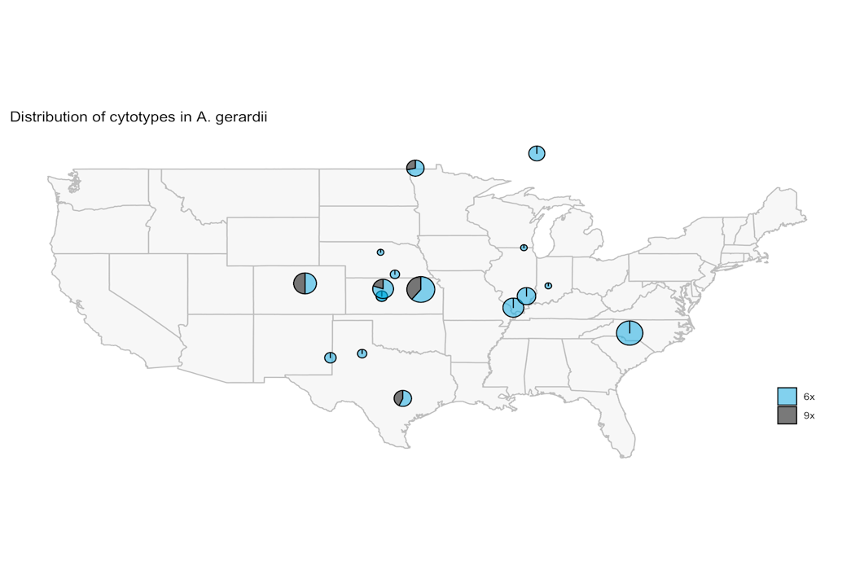

**Figure 1.** Distribution of *A. gerardii* cytotypes in sampled populations. The size of the circle is proportional to sample size.

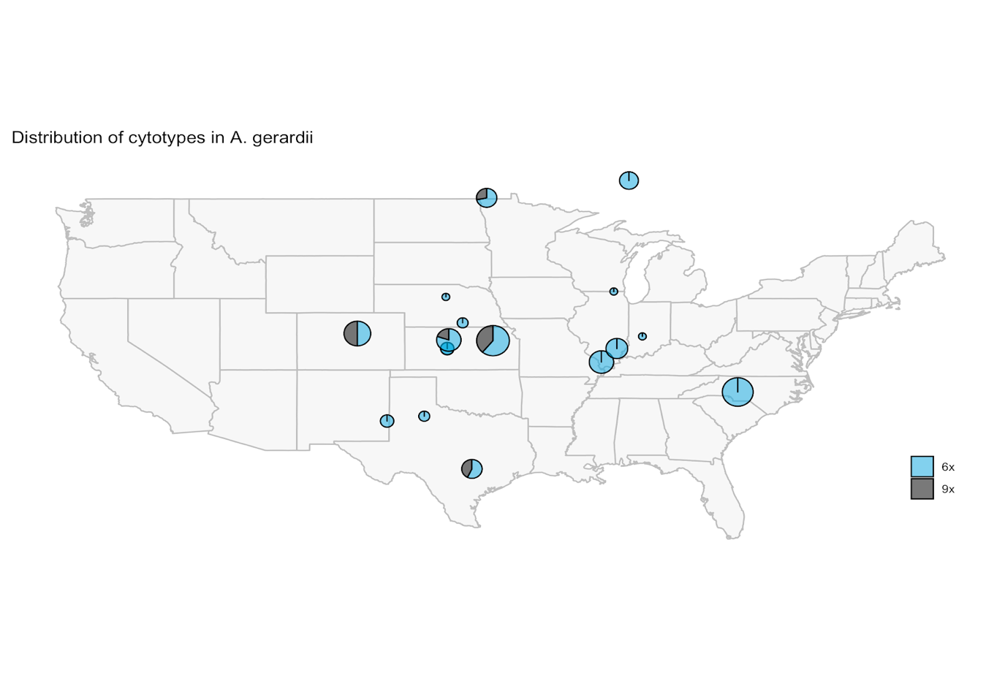

Additional Sample Collection

To evaluate the relationship between ploidy and environment in a common garden experiment, larger sample sizes of each cytotype are required for sufficient statistical power. I will sample additional individuals from two populations to raise the number of each cytotype within that population to ten (n=10). I will apply for the appropriate permits for sample collection in September 2020. Twenty individuals in each population will be marked and young leaf tissue will be collected for genome size analysis. The tissue will be shipped to UC Davis flash frozen in liquid nitrogen. Upon arrival, it will be lyophilized and flow cytometry will be completed on the lyophilized tissue. Individuals of the appropriate cytotype will be dug up and brought to the Donald Danforth Plant Science Center. Each individual will be cloned once so there are two replicates of each genotype.

Common Garden Experiment

Clones of each individual were shipped to UC Davis in August-November 2019 for a phenotyping trial to determine the best phenotypes for a common garden. The phenotyping trial will take place in March-April 2020. The phenotypes to be evaluated are leaf nitrogen and carbon content, turgor loss point, green-up time, flowering time, and relative growth rate following standard methods[11,12](https://paperpile.com/c/OuC74R/cL7Z+YIZo). A phenotype will be selected for the garden if it shows sufficient variation within and between populations.

The 140 individuals plus the additional samples collected from two populations will be planted in a randomized block design at the USDA Plant Genetics Research Unit in Columbia, MO. There will be two replicates for each individual. The field will be planted in the summer of 2020 and will not be measured until the spring of 2021 to allow them to become established through one winter[12](https://paperpile.com/c/OuC74R/YIZo). Plants will be phenotyped using the methods and traits described in the phenotyping trial. The phenotyping data will be used to test for phenotypic differences among populations and between cytotypes within a population using a linear mixed model.

Environmental Association

The WGS data in combination with the phenotyping data will be used in BAYENV2 software to measure population differentiation and identify markers that have a signature of local adaptation associated with environmental variables[9](https://paperpile.com/c/OuC74R/XtAD). These results can be validated using the phenotype data collected in the common garden. **Expected Completion Date:** Spring 2022

**Plans for Collection and Disposition of the Voucher Specimens**

One flowering individual from each of the two populations resampled will be collected as a voucher specimen with approval of appropriate permits. Each individual will be placed in a plant press with multiple tillers, leaves, rhizome, and some roots and marked with a collection number.  The recommended Data Sheet for Plant Collections from the Center for Plant Biodiversity will be used to record the appropriate collection information including: collector, collection number, date, specific epithet and authority, exact location, habitat, and plant description. All collected plants will be pressed immediately upon collection. The press will be brought back to the Center for Plant Diversity Facilities for drying, freezing, and then mounting. These methods will be verified with the Center for Plant Diversity prior to collection.

**References**

**[1]** Wood *et al.* (2009) *Proc. Natl. Acad. Sci.* **[2]** Mayrose *et al.* (2011) *Science* **[3]** Mayrose *et al.* (2011) *New Phytol.* **[4]** Arrigo & Barker (2012) *Curr. Opin. Plant Biol.* **[5]** Soltis *et al.* (2011) *New Phytol* **[6]** Charlesworth & Willis (2009) *Nat. Rev.* **[7]** Weaver (1968) **[8]** McAllister et al. (2015) *Am. J. Bot.* **[9]** Günther & Coop (2013) *Genetics* **[10]** Bartlett *et al.* (2014) *Ecol Lett.* **[11]** Cornelissen *et al.* (2003) *Aust. J. Bot.* **[12]** Lowry *et al.* (2019) *Proc. Natl. Acad. Sci.*

Applicant’s qualifications to carry out the proposed research

I am well-prepared to complete this project with a good chance of success because I have developed the skill sets and knowledge required for experimental design, data collection, and data analysis. During my undergrad, I conducted research on a polyploid complex composed of the genera *Bothriochloa, Capillipedium,* and *Dichanthium* (Poaceae). I developed a strong understanding of the discussions surrounding polyploidy as well as experience working with members of Poaceae. As I began to develop my dissertation work on polyploidy at UC Davis, I took coursework in population genetics and experimental design. These courses have aided the development of my experimental design and hypotheses.

I have also developed the skills required for my data collection: sample collection, flow cytometry, and phenotyping. Alongside my polyploid research in undergrad, I assisted monitoring rare plant and endangered species for the North Carolina Plant Conservation Program and assisted in tissue collection for population genetic studies on the protected species *Liatris helleri, Geum geniculatum,* and *Spiraea virginiana.* This opportunity taught me appropriate field edicate and sample collection techniques. In graduate school, I have been trained on flow cytometry through the UC Davis Comprehensive Cancer Center and I have a working protocol for *A. gerardii*. Additionally, I will be learning to measure turgor loss point and leaf nitrogen and carbon content from a collaborator in March 2020.

 Finally, I have developed the appropriate computational and statistical skills to analyze data from this experiment. I have taken a course in statistical thinking and attended the Summer Institute for Statistical Genetics at the University of Washington where I took courses in population and quantitative genetics. I have also learned to code in both Python and R and developed bioinformatic pipelines for analysis of WGS data. I have the skills and knowledge required for all aspects of the proposed research, therefore I have a high chance of success.

Proposed Budget

|  |  |  |
| --- | --- | --- |
| **Item** | **Description** | **Expense** |
| Airfare | Airline tickets to 2 sampling locations and Columbia, MO (common garden location) | $1200 |
| Rental car | Transport to each sampling location from the airport assuming $40 a day | $240 |
| Lodging | Campsite fees and hotel costs for 2 trips to sample populations and 1 trip to the common garden in Columbia, MO | $560 |
|  | **Total Expenses** | $2000 |